A

Mini Project On

#### PLASTIC DETECTION USING DEEP LEARNING

(Submitted in partial fulfillment of the requirements for the award of Degree)

BACHELOR OF TECHNOLOGY

In

COMPUTER SCIENCE AND ENGINEERING (AI&ML)

By

SYED TALHA AHMED (207R1A66H5)

DEVULAPALLI SRINIDHI (207R1A66D3)

JETTEM SAI TEJA (207R1A66E4)

Under the Guidance of

**Mr.D. BABU RAO**

(Associate Professor)

##### DEPARTMENT OF COMPUTER SCIENCE AND ENGINEERING (AI&ML)

**CMR TECHNICAL CAMPUS UGC AUTONOMOUS**

(Accredited by NAAC, NBA, Permanently Affiliated to JNTUH, Approved by AICTE, New Delhi) Recognized Under Section 2(f) & 12(B) of the UGCAct.1956, Kandlakoya (V), Medchal Road, Hyderabad-501401.

**2020-2024**

**DEPARTMENT OF COMPUTER SCIENCE AND ENGINEERING (AI&ML)**



#### CERTIFICATE

This is to certify that the project entitled **“PLASTIC DETECTION USING DEEP LEARNING”** being submitted by **SYED TALHA AHMED (207R1A66H5) , DEVULAPALLI SRINIDHI (207R1A66D3) & JETTEM SAI TEJA (207R1A66E4)** in partial fulfillment of the requirements for the award of the degree of B.Tech in Computer Science and Engineering (AI&ML) to the Jawaharlal Nehru Technological University Hyderabad, is a record of bonafide work carried out by them under our guidance and supervision during the year 2022-23.

The results embodied in this thesis have not been submitted to any other University or Institute for the award of any degree or diploma.

**Mr.D. Babu Rao Dr. S Rao Chintalapudi**

(Associate Professor) HOD CSE(AI&ML)

INTERNAL GUIDE

**EXTERNAL EXAMINER**

**Submitted for viva voice Examination held on**

##### ACKNOWLEDGEMENT

Apart from the efforts of us, the success of any project depends largely on the encouragement and guidelines of many others. We take this opportunity to express our gratitude to the people who have been instrumental in the successful completion of this project.

We take this opportunity to express my profound gratitude and deep regard to my guide **Mr.D. Babu Rao,** Associate Professor for his exemplary guidance, monitoring and constant encouragement throughout the project work. The blessing, help and guidance given by him shall carry us a long way in the journey of life on which we are about to embark.

We also take this opportunity to express a deep sense of gratitude to the Project Review Committee (PRC) **Dr. G. Vinoda Reddy, Dr. K. Mahesh, Md. Hafeena & D. Babu Rao** for their cordial support, valuable information and guidance, which helped us in completing this task through various stages.

We are also thankful to **Dr. S Rao Chintalapudi,** Head, Department of Computer Science and Engineering (AI&ML) for providing encouragement and support for completing this project successfully.

We are obliged to **Dr. A. Raji Reddy,** Director for being cooperative throughout the course of this project. We also express our sincere gratitude to Sri. **Ch. Gopal Reddy,** Chairman for providing excellent infrastructure and a nice atmosphere throughout the course of this project.

The guidance and support received from all the members of **CMR Technical Campus** who contributed to the completion of the project. We are grateful for their constant support and help.

Finally, we would like to take this opportunity to thank our family for their constant encouragement, without which this assignment would not be completed. We sincerely acknowledge and thank all those who gave support directly and indirectly in the completion of this project.

###### SYED TALHA AHMED (207R1A66H5)

**DEVULAPALLI SRINIDHI (207R1A66D3)**

**JETTEM SAI TEJA (207R1A66E4)**

##### ABSTRACT

Plastic isn’t as simple as everyone assume. The world now produces more than 380 million tons of plastic, half of this is utilized to make one-use items such as polythene bags, mugs, and straws. Every year, at least 8 million tons of plastic wind up in our oceans, which end up as pollutants, entering our natural environment. Thus, it is necessary to handle such kind of massively produced material. There are 7 major categories of plastics. Every single one of them is distinct from the others. Some are reusable, but others could leach harmful compounds if exposed to extreme temperatures.

Some materials are easily recyclable, while others require more complex and delicate processing during the recycling process. Although scientists are actively striving to develop the optimum method and strategy for recycling all of those forms of plastic, recycling programs mostly accept Polyethylene Terephthalate (1-PET) and High-Density Polyethylene (HDPE) (2-HDPE).

Plastic categorization by hand is a time-consuming and costly operation. That’s why we need an automated sorting technique in order to classify it to increase recycling, image processing and artificial intelligence, particularly deep learning technique, are being used. This is an energy conserving technique. Plastic components are the most problematic in home waste, and the most common forms are polyethylene, polypropylene, and polystyrene. We presented a strategy for identifying garbage in portable gadgets that could be useful in resolving urban waste issues.

|  |  |  |
| --- | --- | --- |
| **FIGURE NO** | **FIGURE NAME** | **PAGE NO** |
| Figure 3.1 | Project Architecture for Plastic  Detection using deep learning. | 7 |
|  |  |  |
| Figure 3.2 | Use Case Diagram for Plastic  Detection using deep learning. | 8 |
| Figure 3.3 | Class Diagram for Plastic | 9 |
|  | Detection using deep learning. |  |
| Figure 3.4 | Sequence diagram for Plastic  Detection using deep learning. | 10 |
| Figure 3.5 | Activity diagram for Plastic  Detection using deep learning. | 11 |

|  |  |  |
| --- | --- | --- |
| **SCREENSHOT NO.** | **SCREENSHOT NAME** | **PAGE NO**. |
| Screenshot 5.1 | Student Recognised | 16 |
| Screenshot 5.2 | Recognised and Displayed With a Message | 16 |
| Screenshot 5.3 | Student Face Recognised | 17 |
| Screenshot 5.4 | Camera Dialogue Box | 17 |
| Screenshot 5.5 | Data stored in log file | 18 |

###### ABSTRACT i

LIST OF FIGURES ii

LIST OF SCREENSHOTS iii

1. INTRODUCTION 1
   1. PROJECT SCOPE 1
   2. PROJECT PURPOSE 1
   3. PROJECT FEATURES 1
2. SYSTEM ANALYSIS 2
   1. PROBLEM DEFINITION 2
   2. EXISTING SYSTEM 2
      1. LIMITATIONS OF THE EXISTING SYSTEM 3
   3. PROPOSED SYSTEM 3
      1. ADVANTAGES OF PROPOSED SYSTEM 3
   4. FEASIBILITY STUDY 4
      1. ECONOMIC FEASIBILITY 4
      2. TECHNICAL FEASIBILITY 5
      3. SOCIAL FEASIBILITY 5
   5. HARDWARE & SOFTWARE REQUIREMENTS 5
      1. HARDWARE REQUIREMENTS 5
      2. SOFTWARE REQUIREMENTS 6
3. ARCHITECTURE 7
   1. PROJECT ARCHITECTURE 7
   2. DESCRIPTION 7
   3. USE CASE DIAGRAM 8
   4. CLASS DIAGRAM 9
   5. SEQUENCE DIAGRAM 10
   6. ACTIVITY DIAGRAM 11
4. IMPLEMENTATION 12
   1. SAMPLE CODE 12
5. SCREENSHOTS 16
6. TESTING 19
   1. INTRODUCTION TO TESTING 19
   2. TYPES OF TESTING 19
      1. UNITT TAEBSTLINEGOF CONTENTS 19
      2. INTEGRATION TESTING 20
      3. FUNCTIONAL TESTING 20
   3. TEST CASES 21
      1. CLASSIFICATION 21
7. CONCLUSION & FUTURE SCOPE 22
   1. PROJECT CONCLUSION 22
   2. FUTURE SCOPE 22
8. REFERENCES 23
   1. REFERENCES 23
   2. GITHUB LINK 23

# INTRODUCTION

#### INTRODUCTION

##### PROJECT SCOPE

This project is titled “Plastic detection using deep learning”. Plastic components are the most problematic in home waste, and the most common forms are polyethylene, polypropylene, and polystyrene. We presented a strategy for identifying garbage in portable gadgets that could be useful in resolving urban waste issues.

##### PROJECT PURPOSE

This project has been developed to identify Deep learning based methods that can extract more complicated features. Deep learning is making crucial advances in solving problems that have restricted the best attempts of the artificial intelligence community for many years. It has proven to be excellent at revealing complex structures in high-dimensional data and is therefore applicable to lots of domains of science, business and government.

##### PROJECT FEATURES

The main features of this project are that this model classifies the It addresses the problem of learning hierarchical representations with a single algorithm or a few algorithms and has mainly beaten records in image recognition, natural language processing, semantic segmentation and many other real world scenarios. There are different deep learning approaches like Convolutional Neural Network(CNN), Stacked Autoencoder, and Deep Belief Network (DBN). CNN mostly used algorithms in image and image recognition.

## SYSTEM ANALYSIS

##### SYSTEM ANALYSIS

**SYSTEM ANALYSIS**

System Analysis is the important phase in the system development process. The System is studied to the minute details and analyzed. The system analyst plays an important role of an interrogator and dwells deep into the working of the present system. In analysis, a detailed study of these operations performed by the system and their relationships within and outside the system is done. A key question considered here is, “what must be done to solve the problem?” The system is viewed as a whole and the inputs to the system are identified. Once analysis is completed the analyst has a firm understanding of what is to be done.

##### PROBLEM DEFINITION

A general statement of plastic detection problem can be formulated as the given images of a scene, identify or verify one or more objects in the scene or in any live capturing devices using a stored database of those authorised objects.

.

##### EXISTING SYSTEM

Plastic dataset is considered to make the dataset segmentation, include the CNN model perform in the dataset. The remaining steps after the segmentation the particular region are taken in the dataset. That regions are covered by mask it detects plastic. And also, we classify the plastic into PS, PP, PVC, PET, LDPE, HDPE and other. A report on the impact of plastic pollution, one of the first to document the impact of discarded plastic on the health of the poorest people in the world, estimates that between 400,000 and one million people die every year because of diseases and accidents linked to poorly managed waste in developing countries.

###### DISADVANTAGES OF EXISTING SYSTEM

• Difficult to Monitor Performance - It is not easy for managers to monitor their staff’s progress and performance without them being in the same office space.

• To avoid all these limitations and make the working more accurately the system needs to be computerized in a better way.

• Consumes large volume of paper work. Needs manual calculations.

• This is especially escalated if the job role requires a lot of “background duties” that can’t be monitored on a work’s system. Financial burden on the world, Morbidity and mortality Social and mental distance between people.

##### PROPOSED SYSTEM

In our proposed work, the simplified model for skin cancer identification is used. In this model the preparation of the input image for validation and learning is the important phase. In 13 addition to convolutional layer, we have use max-pooling layer, activation function, drop-out layer, SoftMaxlayer. The convolutional layer extracts the feature and passes it to the next layer. The system as a whole is examined, and the system's inputs are recognised. The different procedures are linked to the organisations' outputs. The goal of system analysis is to become aware of the problem, identify the important and decisional variables, analyse and synthesise the numerous components, and come up with an optimal or at least adequate solution or plan of action

###### ADVANTAGES OF THE PROPOSED SYSTEM

• Avoiding local storage of data.

• By reducing the costs of storage, maintenance and personnel.

• It reduces the chance of losing data by hardware failures.

•Life style modifications

• Health awareness

• Importance of health

• Advantages of real-time and fast and are suitable for data analysis of a large number of people.

• The sensitivity, spatial resolution and accuracy of its prediction result is improved

##### FEASIBILITY STUDY

The feasibility of the project is analyzed in this phase and a business proposal is put forth with a very general plan for the project and some cost estimates. During system analysis the feasibility study of the proposed system is to be carried out. This is to ensure that the proposed system is not a burden to the company. Three key considerations involved in the feasibility analysis:

* EconomicFeasibility
* TechnicalFeasibility
* SocialFeasibility

###### ECONOMIC FEASIBILITY

The developing system must be justified by cost and benefit. Criteria to ensure that effort is concentrated on a project, which will give best, return at the earliest. One of the factors, which affect the development of a new system, is the cost it would require.

The following are some of the important financial questions asked during preliminary investigation:

* + - * The costs conduct a full system investigation.
      * The cost of the hardware and software.
      * The benefits in the form of reduced costs or fewer costly errors.

Since the system is developed as part of project work, there is no manual cost to spend for the proposed system. Also all the resources are already available, it give an indication that the system is economically possible for development.

###### TECHNICAL FEASIBILITY

This study is carried out to check the technical feasibility, that is, the technical requirements of the system. Any system developed must not have a high demand on the available technical resources. The developed system must have a modest requirement, as only minimal or null changes are required for implementing this system.

###### BEHAVIORAL FEASIBILITY

This includes the following questions:

* + - * Is there sufficient support for the users?
      * Will the proposed system cause harm?

The project would be beneficial because it satisfies the objectives when developed and installed. All behavioral aspects are considered carefully and conclude that the project is behaviorally feasible

##### HARDWARE & SOFTWARE REQUIREMENTS

###### HARDWARE REQUIREMENTS:

Hardware interfaces specify the logical characteristics of each interface between the software product and the hardware components of the system. The following are some hardware requirements.

* + - * Processor : Intel Core I5 and above
      * Hard disk : 8GB and above
      * RAM : 8GB and above
      * Input devices : Keyboard, mouse.

##### SOFTWARE REQUIREMENTS:

Software Requirements specifies the logical characteristics of each interface and software components of the system. The following are some software requirements,

* Operating system : Windows 8 and above
* Languages : Python, Html, CSS
* Tools : Python IDEL3.7 version, Anaconda - Jupyter, Spyder

## ARCHITECTURE

##### ARCHITECTURE

##### PROJECT ARCHITECTURE

This project architecture shows the procedure followed for classification, starting from input to final prediction.

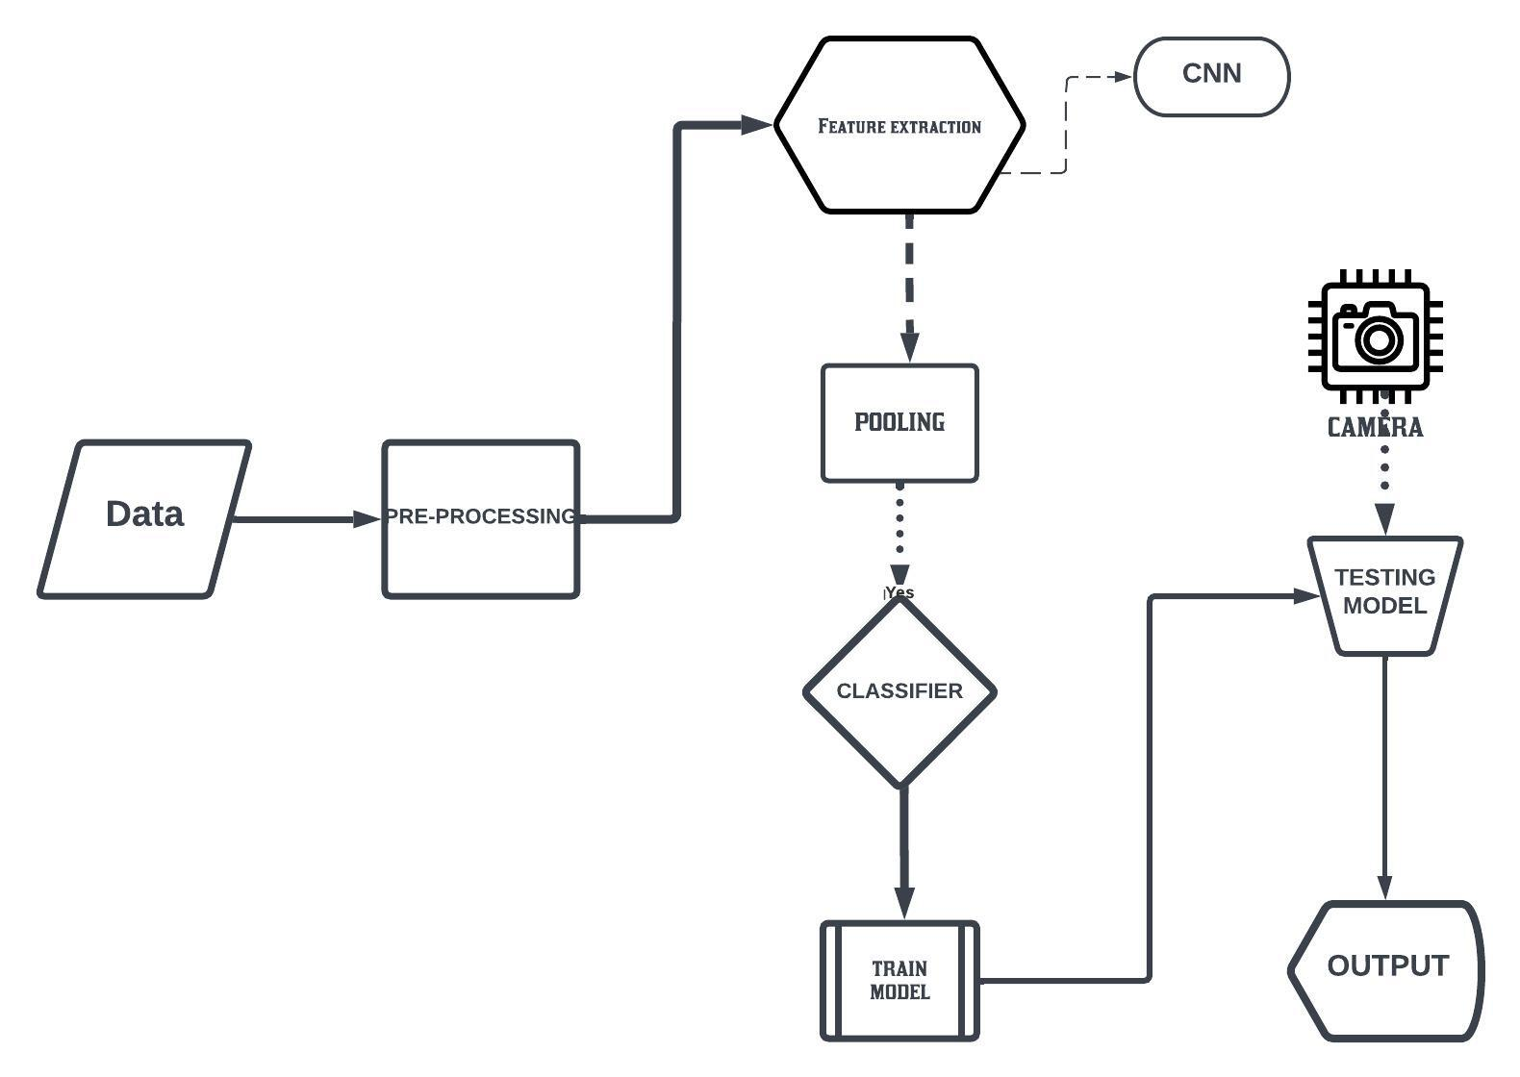

Figure 3.1: Project Architecture of Plastic detection using deep learning

###### DESCRIPTION

This project is totally based upon identifying the recognised authorized faces. The model is built to recognize faces as part of the biometric security system and then produce a voice message for every recognized face. The model is built with libraries like face recognition, pyttsx, os, opencv, pandas, numpy etc. Each library is used for a specific purpose for example face recognition is used for face detection and manipulation of images. The pyttsx library is used to convert text to speech which is the reason the model produces voice output.

###### USE CASE DIAGRAM

In the use case diagram, we have basically one actor who is the user in the trained model.

A use case diagram is a graphical depiction of a user's possible interactions with a system. A use case diagram shows various use cases and different types of users the system has. The use cases are represented by either circles or ellipses. The actors are often shown as stick figures.

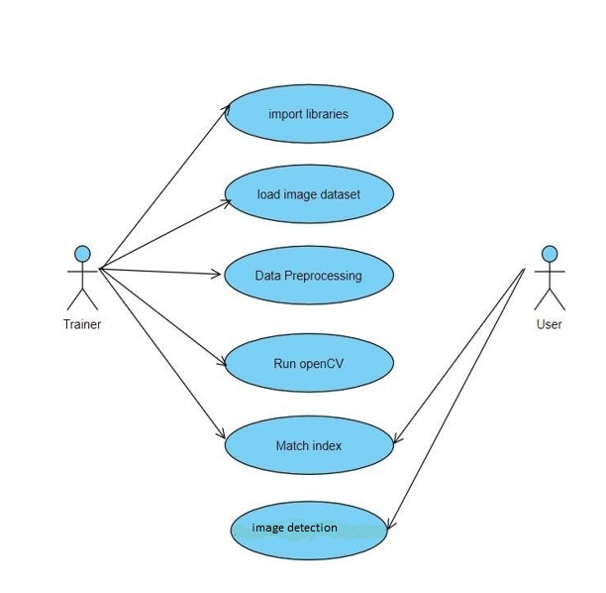

Figure 3.2: Use Case Diagram for Plastic detection using deep learning.

##### CLASS DIAGRAM

Class diagram is a type of static structure diagram that describes the structure of a system by showing the system’s classes, their attributes, operations(or methods), and the relationships among objects.

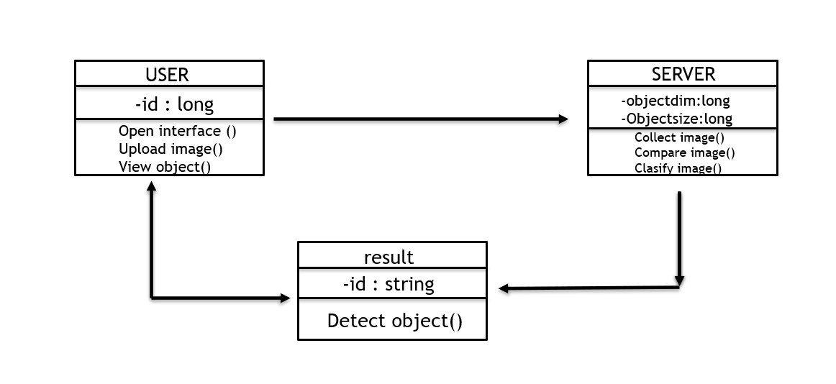

Figure 3.3: Class Diagram for Plastic detection using deep learning.

##### SEQUENCE DIAGRAM

A sequence diagram shows object interactions arranged in time sequence. It depicts the objects involved in the scenario and the sequence of messages exchanged between the objects needed to carry out the functionality of the scenario. Sequence diagrams are typically associated with use case realizations in the logical view of the system under development.

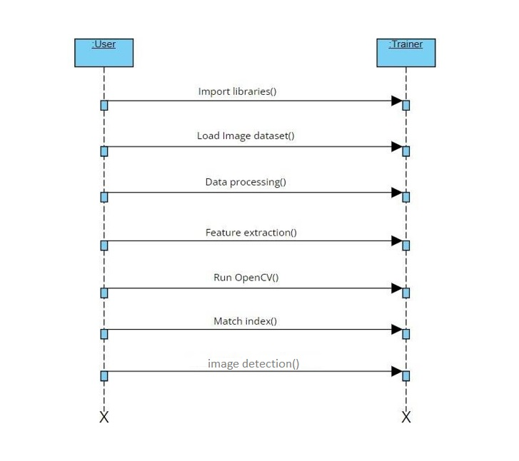.

Figure 3.4: Sequence Diagram for Plastic detection using deep learning.

###### ACTIVITY DIAGRAM

Activity diagrams are graphical representations of workflows of stepwise activities and actions with support for choice, iteration and concurrency. They can also include elements showing the flow of data between activities through one or more data stores.

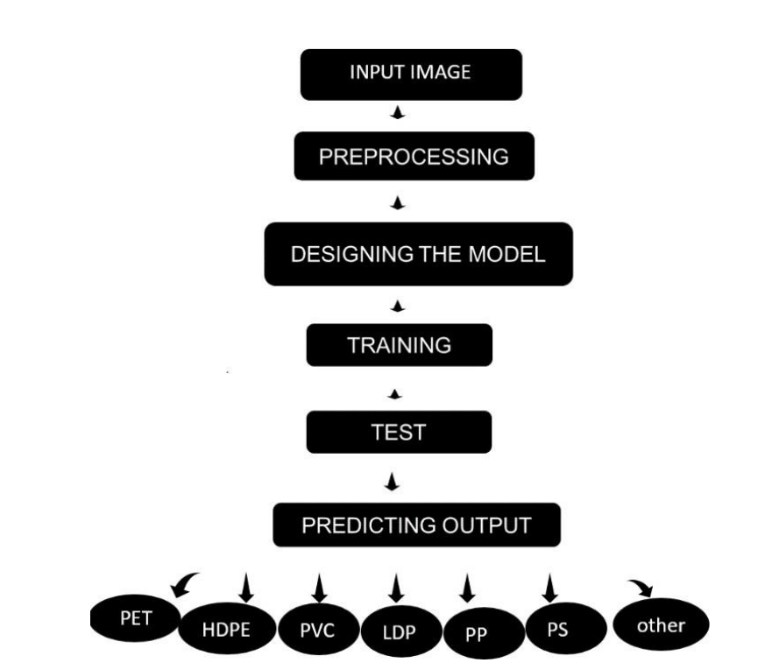

Figure 3.5: Activity Diagram for Plastic detection using deep learning.

## IMPLEMENTATION

##### 4.1 SAMPLE CODE

# Part 1 - Building the CNN

import tensorflow as tf

import pandas as pd

import numpy as np

import matplotlib.pyplot as plt

from keras.layers import Dropout

# Initialising the CNN

classifier =tf.keras.Sequential()

input_shape_x=127

input_shape_y=127

#(X_train, y_train), (X_test, y_test) = "/content/drive/MyDrive/classification/train" classifier.add(tf.keras.layers.Conv2D(16, (3,3), input_shape = (input_shape_x, input_shape_y, 3), activation = 'relu'))

classifier.add(tf.keras.layers.MaxPooling2D(pool_size = (2, 2))) classifier.add(tf.keras.layers.Conv2D(32, (3, 3), activation = 'relu')) classifier.add(tf.keras.layers.MaxPooling2D(pool_size = (2, 2)))

classifier.add(tf.keras.layers.Conv2D(64, (3, 3), activation = 'relu')) classifier.add(tf.keras.layers.MaxPooling2D(pool_size = (2, 2)))

# Step 3 - Flattening

classifier.add(tf.keras.layers.Flatten())

# Step 4 - Full connection node

classifier.add(tf.keras.layers.Dense(units = 256, activation = 'relu')) classifier.add(tf.keras.layers.Dropout(0.1))

classifier.add(tf.keras.layers.Dense(units = 64, activation = 'relu'))

#importany this retrives most info and ignores unecessary things

# classifier.add(tf.keras.layers.Dense(43, activation="softmax"))

classifier.add(tf.keras.layers.Dense(units = 7, activation = 'softmax'))

# Compiling the CNN

classifier.compile(loss="categorical_crossentropy", optimizer="adam", metrics=["accuracy"])

# Part 2 - Fitting the CNN to the images

#classifier.compile(optimizer = 'adam', loss = 'categorical_crossentropy', metrics = ['acc'])

# Part 2 - Fitting the CNN to the images

from keras.preprocessing.image import ImageDataGenerator

train_datagen = ImageDataGenerator(rescale = 1./255,

shear_range = 0.2,

zoom_range = 0.2,

horizontal_flip = True)

test_datagen = ImageDataGenerator(rescale = 1./255)

training_set =

train_datagen.flow_from_directory('/content/drive/MyDrive/classification/train',

target_size = (input_shape_x, input_shape_y),

batch_size = 4, class_mode = 'categorical')

#binary

test_set = test_datagen.flow_from_directory('/content/drive/MyDrive/classification/test',

target_size = (input_shape_x,input_shape_y),

batch_size = 8, class_mode = 'categorical')

#binary

epochs = 15

# history = classifier.fit(training_set, epochs=epochs, batch_size=64, validation_data=(test_set))

history=classifier.fit(training_set,

steps_per_epoch =153,

epochs = 180,

validation_data = test_set,

validation_steps = 58)

## SCREENSHOTS

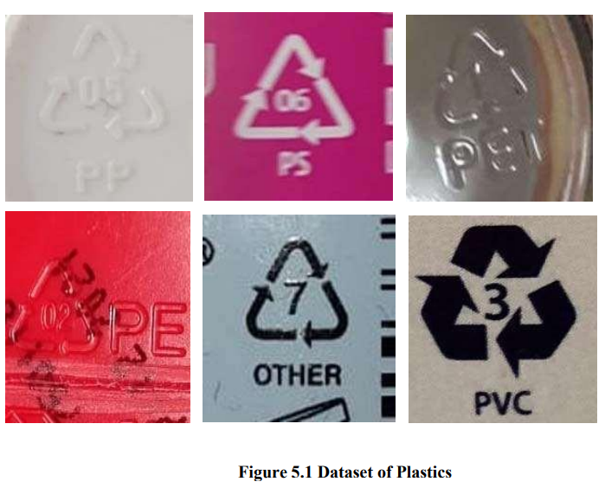

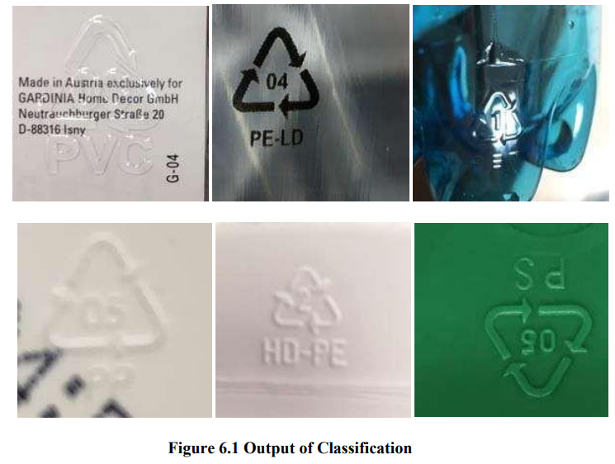

Screenshot 5.2: Output classification

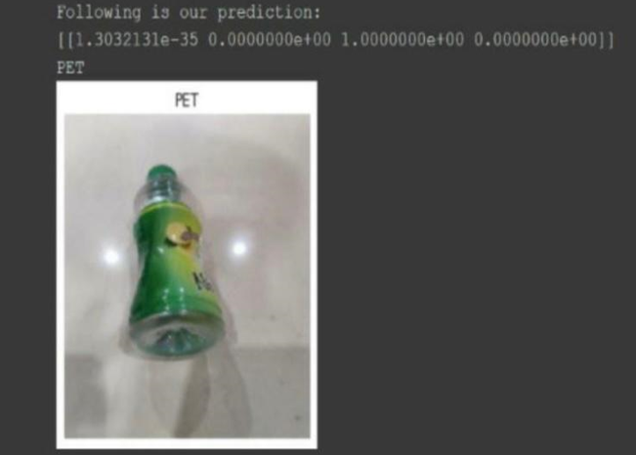

Screenshot 5.3: output

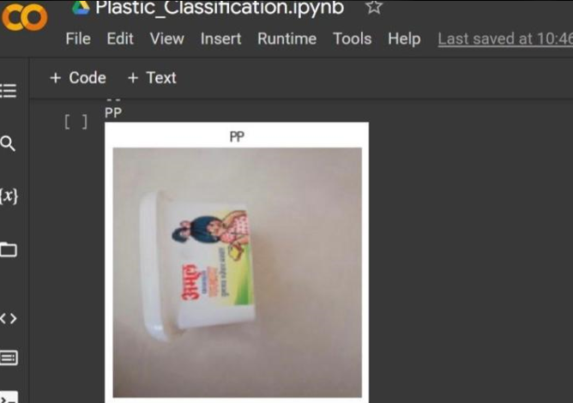

Screenshot 5.4: output

## TESTING

#### TESTING

##### INTRODUCTION TO TESTING

The purpose of testing is to discover errors. Testing is the process of trying to discover every conceivable fault or weakness in a work product. It provides a way to check the functionality of components, subassemblies, assemblies and/or a finished product. It is the process of exercising software with the intent of ensuring that the Software system meets its requirements and user expectations and does not fail in an unacceptable manner. There are various types of tests. Each test type addresses a specific testing requirement.

##### TYPES OF TESTING

###### UNIT TESTING

Unit testing involves the design of test cases that validate that the internal program logic is functioning properly, and that program inputs produce valid outputs. All decision branches and internal code flow should be validated. It is the testing of individual software units of the application .It is done after the completion of an individual unit before integration. This is a structural testing that relies on knowledge of its construction and is invasive. Unit tests perform basic tests at component level and test a specific business process, application and/or system configuration. Unit tests ensure that each unique path of a business process performs accurately to the documented specifications and contains clearly defined inputs and expected results.

###### INTEGRATION TESTING

Integration tests are designed to test integrated software components to determine if they actually run as one program. Integration tests demonstrate that although the components were individually satisfactory, as shown by successfully unit testing, the combination of components is correct and consistent. Integration testing is specifically aimed at exposing the problems that arise from the combination of components.

###### FUNCTIONAL TESTING

Functional tests provide systematic demonstrations that functions tested are available as specified by the business and technical requirements, system documentation, and user manuals.

Functional testing is centered on the following items:

Valid Input : identified classes of valid input must be accepted.

Invalid Input

: identified classes of invalid input must be rejected.

Functions : identified functions must be exercised.

Output : identified classes of application outputs must be exercised.

Systems/Procedures: interfacing systems or procedures must be invoked. Organization and preparation of functional tests is focused on requirements, key functions, or special test cases.

##### TEST CASES

###### CLASSIFICATION

|  |  |  |  |  |
| --- | --- | --- | --- | --- |
| Test case  ID | Test case name | Purpose | Input | Output |
| 1 | Plastic detection | To detect objects. | The user gives the input in the form of a image using open cv. | An output is  Object detection |
| 2 | Plastic detection | To detect objects. | The user gives the input in the form of a image using open cv. | An output is  Object detection |

1. **CONCLUSION**

##### CONCLUSION & FUTURE SCOPE

##### PROJECT CONCLUSION

Various factors in the environment result in the transformation of model concepts and change of performance. The factors that drive the model should be understood to make certain decisions. Currently, the interpretability research on plastic waste identification models is a big gap in this field and must be explored. In the plastic type recognition field, deep learning models can be applied to identify plastic. However, these algorithms are still a ``black box'' to generate predictions on the basis of input data.

There is no specify interpretation on what plastic waste detection features does the deep learning model as a basis for judgment. The development of deep learning should be trustworthy and explainable. Making the algorithm public and transparent in decisionmaking will give users reliability and security. Interpretability research on plastic waste detection can resolve prejudices and auditing brought about by artificial intelligence Interpretability makes artificial intelligence open and transparent in legal, moral, and philosophical aspects.

##### FUTURE SCOPE

The future enhancement would be integrating with the video sequencing. From this project the advancement to the image recognition system can be a great use in many applications like shopping malls, institutes, universities, home applications. The model can effectively deliver voice messages to various faces and an application to look out for.

### BIBLIOGRAPHY

##### 8. BIBLIOGRAPHY

* 1. **REFERENCES**

[1] Solid waste issue: Sources, composition, disposal, recycling, and valorization” 2018 By panelHussein I.Abdel-ShafyaMona S.M.Mansou.

[2] A review on au tomated sorting of source-separated municipal solid waste for recycling” 2016 By Sathish Paulraj Gundupalli 1, Subrata Hait 2, Atul Thakur 3.

[3] Influence of shape and size of the particles on jigging separation of plastics mixture,” 2015 Fernando Pita 1, Ana Castilho 2.

[4] Intelligent solid waste processing using optical sensor based sorting technology,” 2010 Jiu Huang; Thomas Pretz; Zhengfu Bian All Authors.

[5] Advanced waste-splitting by sensor based sorting on the example of the MTPlant oberlaa,” 2020 Janusz Bobulskia and Mariusz Kubanekb .

[6] Upgrading the quality of mixed recycled aggregates from construction and demolition waste by using near-infrared sorting technology,” 2015 InigoVegas,Kris Broosb,Peter Nielsenb, Oliver Lambertz,Amaia Lisbonaa.

[7] Case study: interpretability of fuzzy systems applied to nonlinear modelling and control,” 2017 Krzysztof Cpalka.

[8] Real-time hyperspectral processing for automatic nonferrous material sorting,” 2012Artzai Picon, Aranzazu Bereciartua, Jone Echazarra, Ovidiu Ghita, Paul F. Whelan, Pedro M. Iriondo.

[9] Industrial application for inline material sorting using hyperspectral imaging in the NIR range,” 2005 Petra Tatzer,Markus Wolf,Thomas Panner.

[10] Sorting of polypropylene resins by color in MSW using visible reflectance spectroscopy,” 2010 S. M. Safavi, H. Masoumi, S. S. Mirian, and M. Tabrizchi.

[11] utilization of hyperspectral imaging for impurities detection in secondary plastics,” 2012 S. Serranti, A. Gargiulo, G. Bonifazi, A. Toldy, S. Patachia, and R. Buican.

[12] Characterization of post-consumer polyolefin wastes by hyperspectral imaging for quality control in recycling processes,” 2011 S. Serranti, A. Gargiulo, and G. Bonifazi.

[13] Classification of polyolefins from building and construction waste using NIR hyperspectral imaging system,” 2012 S. Serranti, A. Gargiulo, and G. Bonifazi. 29

[14] Rapid discrimination of plastic packaging ma terials using MIR spectroscopy coupled with independent components analysis (ICA),” 2014 A. Kassouf, J. Maalouly, D. N. Rutledge, H. Chebib, and V. Ducruet.

[15] Deep: convolutional neural network applies to face recognition in small and medium databases,” 2018 M. Wang, Z. Wang, and J. Li.

[16] Application of foreground object patterns analysis for event detection in an innovative video surveil lance system,” 2015 D. Frejlichowski, K. Go´sciewska, P. Forczmanski, and ´ R. Hofman.

[17] PET waste classification method and plastic waste database - WaDaBa,” 2018 J. Bobulski and J. Piatkowski.

[18] Waste classification system using image processing and convolutional neural networks,” 2019 J. Bobulski and M. Kubanek.

[19] CNN use for plastic garbage classification method,” 2019 J. Bobulski and M. Kubanek.

##### GITHUB LINK

https://github.com/talha7887/plasticdetection/blob/main/plastic%20detection%20report.docx